2023
Thank You for desiring and purchasing Thunder Mounts Solution, the new standard for garages around the World!
Thunder Mounts Garage Door Track Mounting Instructions. Take pictures before you start and after pictures and send them to us. Send them to Thunder@Thundermounts.com
Tools/Items Needed: ▪ 9 /16” socket and wrench, ½” socket and wrench and a ratchet wrench. Power drill, socket driver 1/8-inch drill bit, six-foot ladder, contact cement, measuring tape and something to hold the garage track in place. In the box: Two channels, four happy face retainers, four tube pieces, Isolator washers, hardware, instructions and two finish rings.
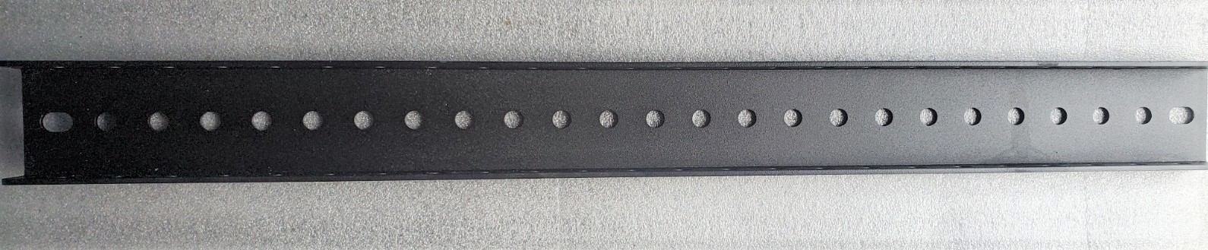
Thunder Mounts Lazur cut channel.
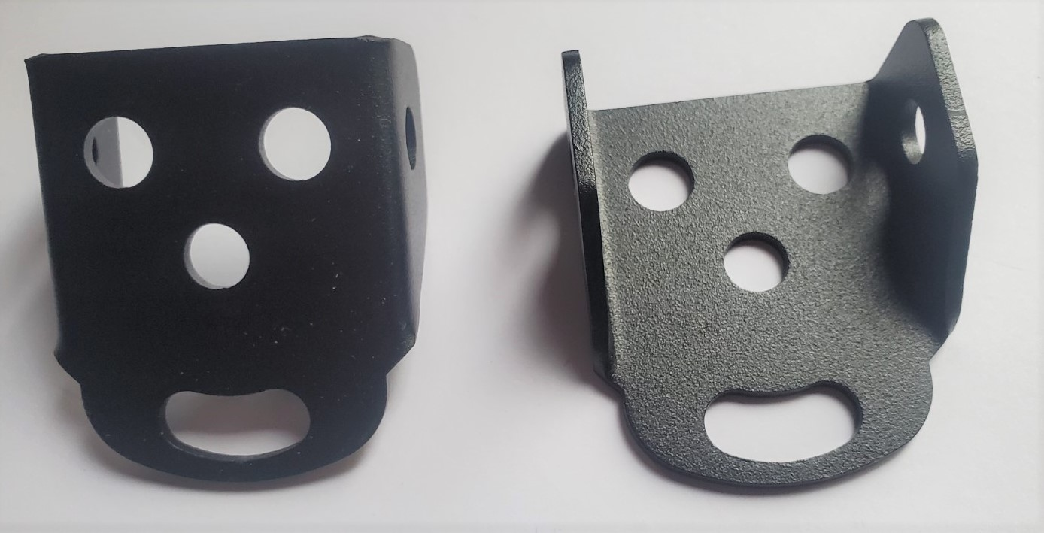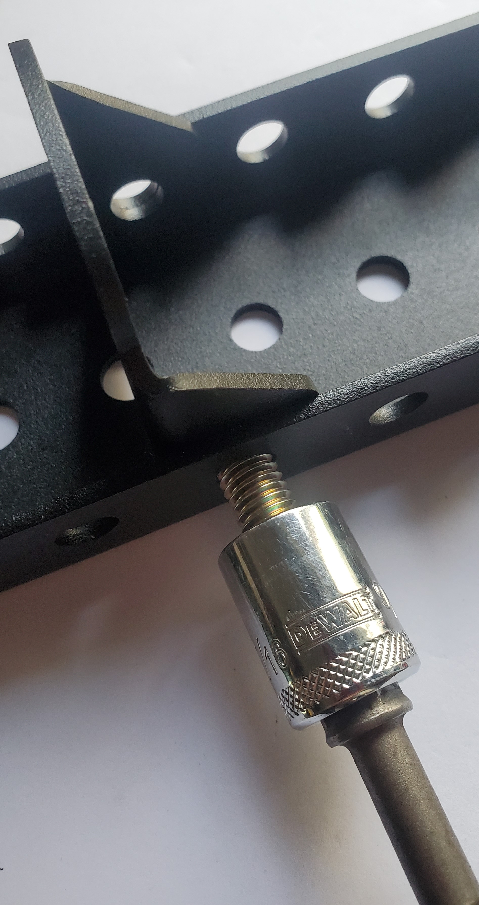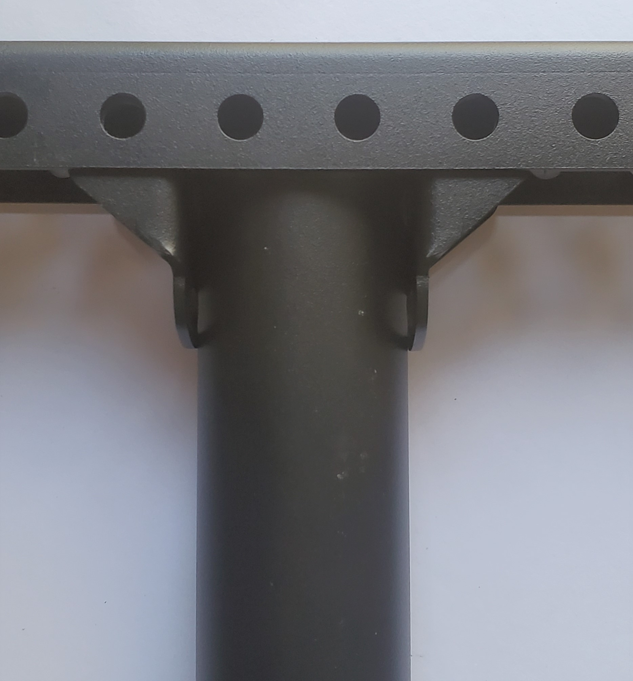
Thunder Mounts Lazur cut retainers.
Thunder Mounts Hardware.
All Thunder Mounts parts are made from 12 gage steel. The channel is made to construction code standard of 24” on center.
Retainers can be placed in the channel one-inch increments left or right.
Thunder Mounts Dual Retainers are designed for maximum strength and stability. Use a driver to put the bolts in. The powder coating makes it tight.
1. Mounting above the ceiling: 1. Start with the door closed to locate the solid / wood /supports above door tracks from where to attach/mount the Thunder Mount Channels safely and securely. (It is mandatory to mount channels horizontal with the door). Retainers attach in the channel facing each other and adjust in one-inch increments left or right.
2. Mark directly above the track where the channels are to be placed. The tubes are placed on the outside of the tracks. Mark the that spot on the ceiling and cut a 2” hole at the exact location for the tubes to go through the ceiling / drywall.
Some Installations need two pieces of wood added to support the “Channels” in the proper direction. This is easily resolved. This is the Right Way! Do this. One Mount to Each Track. Remember the Isolator washers!! Thunder’s Track retainers attached to channel and under channel bolted to the supports and bolted to Tube.
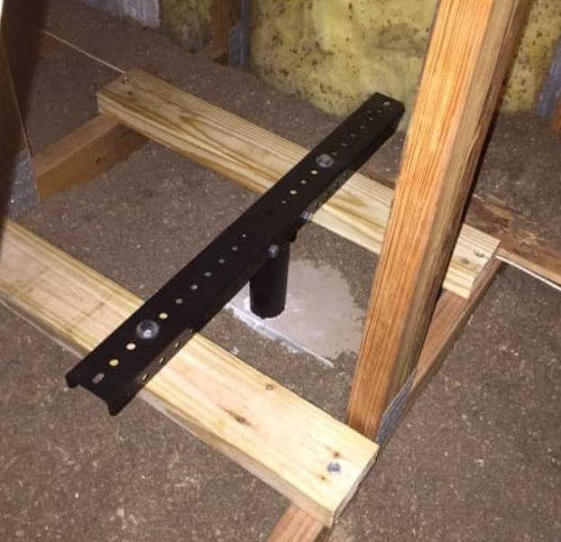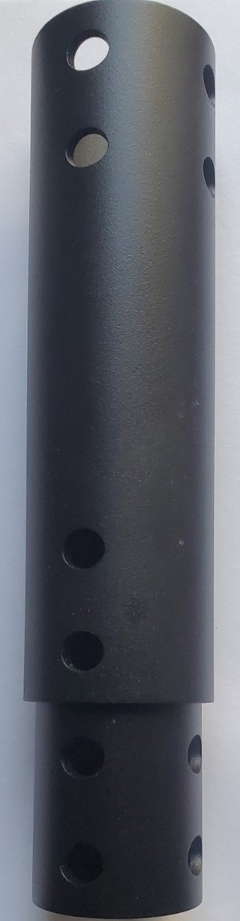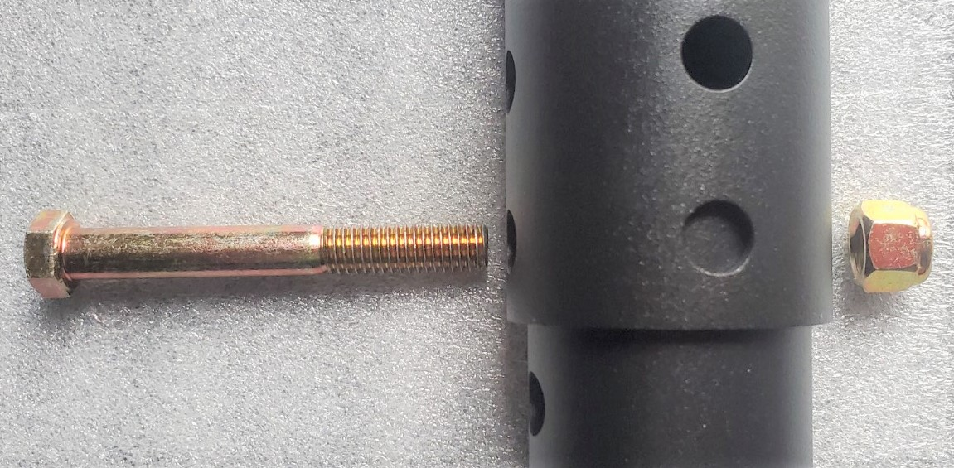Thunder Mounts Lazur Cut Tubes. High quality hardware.
Adjustable tubes. (No cutting needed, no sharp corners, no waste, no injuries.)
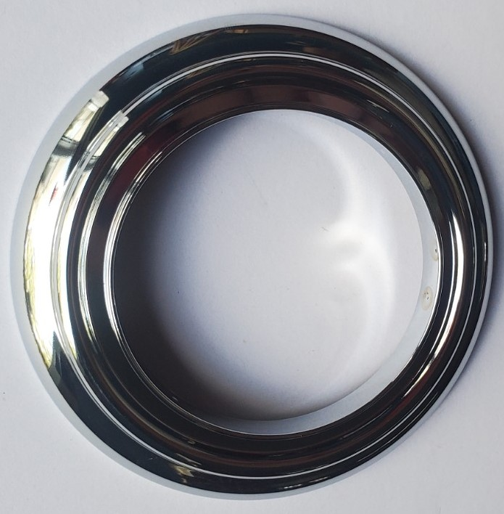Chrome beauty ring is glued to the ceiling.
Track Isolator washers, Retainers bolt facing towards each other. 3. Drill 1/8 x 1-inch-deep holes in the structure to attach the channels. 4. Place the retainers where you need them to be then bolt them in place currently snug but not tight. *First attach “Wider Tube” to the Retainers in the channel the second set of holes of the tube “And Tighten Them Up First.” *Then tighten the retainers in place as needed on the channel then tighten Them well. Retighten everything good and tight. *** (Note)*Secure the nuts and bolts good and tight into the second set of holes of the wider tube with less holes. Now slide in the adjustable tubes bolt together and secure together the adjustable tubes onto the tracks. Recheck all the nuts and bolts and re-tighten them securely.
**There is a procedure to tighten the bolts. First tighten the bolts to the tube then the channel.
Mounting Thunder Tracks below the ceiling: 1. Locate the solid wood supports above the tracks from where to attach Thunder Mounts Channels to support the door tracks. 2. Attach the retainers to the channels directly above with the tubes attached to connect to the outside of the door tracks. The tubes must be attached on the outside of the door tracks. Take your time to be sure with everything together where it will all land. Mark that location and pre-drill the holes with a 1/8-inch drill Bit and drill 1” deep. 4. First loosely bolt the retainers on the channel where needed. 5. Then bolt on the wider Tube into the second set of holes and tighten them up. 6 | P a g e 6. Then tighten up the retainers good and tight. This makes sure the retainers are tight against the tubes. 7. Bolt the adjustable tubes together to door tracks. Gen 3 hardware are 9/16 x 3” bolts for the thick 12 ga. Gen 3 Tubes. Adjust the Height. Recheck all the nuts and bolts and secure them well! Mounting Thunder Mount Garage Tracks:
***“Channels must be installed from left to right”! “Not front to back”! “Not stable front to back”.
Not Recommended! We Recommended Only Mounting Channels Parallel with the Door! Be sure that it is secure and tight and assembled correctly. (Remember that the door and track spacing should be one inch or less). Thunder Mounts Garage Systems LLC. are only made in America. Give us a call if you have any questions. 805-338-6680 Hours: M-F 9-5, 10-2 Sat. Closed Sunday 805-262-2895 PST. thunder@thundermounts.com. Injury and or property damage can occur if installation instructions are not followed properly voids manufactures warranty.
Thank You for desiring and purchasing Thunder Mounts Solution, the new standard for garages around the World.
higher quality standard for your homes garage and take pictures before you start and after pictures and send them to us. Send them to Thunder@Thundermounts.com
Copyright © 2010-2023.THUNDER MOUNTS GARAGE SYSTEMS LLC. All rights reserved

